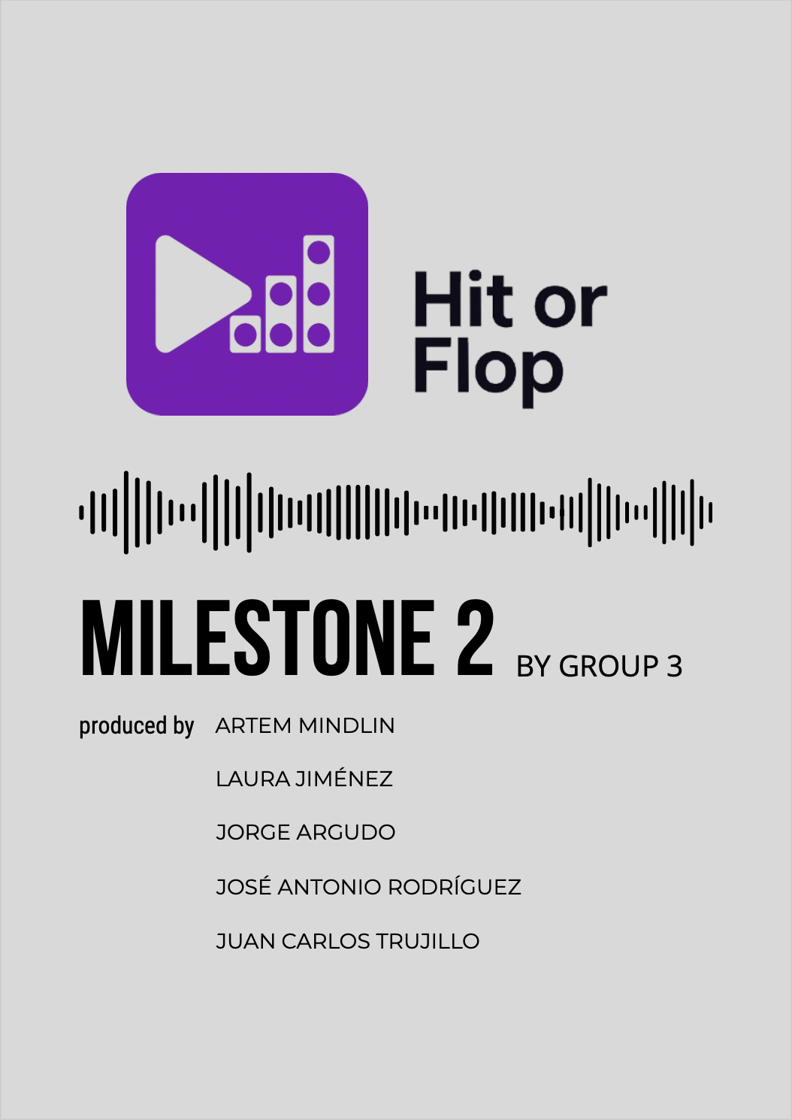

Index of contents
1. Introduction 1
2. Data preparation 1
2.1 Data sources and collection 1
2.2 Data cleaning 1
3. Task description 3
3.1 Minable View 3
3.2 Predicting song popularity 3
3.3 Embedding analysis for evolution of music preferences 3
3.4 Association rule mining for popular song characteristics 4
4. Model prototype and evaluation 4
4.1 Prediction model 5
4.2 Association rule evaluation 6
5. Discussion and deployment mockup 6
6. Use of technology 7
7. Bibliography 7

1. Introduction
Music streaming platforms generate large amounts of data, which provides opportunities to analyze song characteristics and predict their popularity. This project aims to leverage machine learning techniques to predict a song's popularity based on its intrinsic features, create embeddings to account for listener-preferred expressions over time, and generate association rules that provide artists with insights into composing popular songs.
This document presents the first version of a summary on data preparation, model building, evaluation, and implementation prototype.

2. Data preparation

2.1 Data sources and collection
Additional data sources used (in addition to the original dataset provided by the professors) include:
- Spotify API: Provides data on audio features (Loudness, Tempo, etc.). It is also used to collect artists' genres for context.
- Kaggle Datasets: Offers databases like the one initially provided, with a primary focus on song popularity.
- Last.fm API: Provides genre tagging at the song level, improving classification granularity.
- AZLyrics Scraping: Enables the retrieval of song lyrics.
All data gathered from these sources has been cleaned and integrated to support a more effective analysis of the results.

2.2 Data cleaning
The main dataset integrates the 2021 data (originally provided) with equivalent data from 2024 and the popularity of selected songs in 2025. Notably, it focuses on 2021 and 2024 songs due to API limitations and query blocking.
Before starting, and to facilitate the concatenation of the tables from both years, these tables were loaded separately, and columns were created for the non-recorded year (2024 if the data came from 2021 and vice versa).
Beginning with data definition, the 2024 dataset initially contained only audio features and song IDs, lacking information on song titles and artists. To address this, supplementary metadata was retrieved using the Spotify API. Once 2024 and 2021 had the same variables, an additional query was performed to obtain the current popularity value of each audio file, classifying it as popularity_2025. Thus, each song in the final dataset includes its popularity for the corresponding year (2021 or 2024) and the most recent popularity value (2025). If the same song appeared in both 2021 and 2024, the popularity value was calculated as the average of the popularity values from both years. To streamline the dataset and reduce the number of API queries, duplicate song IDs in the same year were identified and systematically removed.
Secondly, a discretization of the popularity values was carried out to facilitate future association rule generation. The following classes and their respective popularity thresholds were defined as FLOP (popularity ≤25), MID (25 < popularity ≤50), MID-HIT (50 < popularity ≤80), and HIT (popularity >80). Also, for the same purpose of enabling association rules, the remaining audio features were discretized, with categories and thresholds defined specifically for each one.
Next, genre acquisition for the songs was conducted, applying count-based filtering to avoid including genres with erroneous or extremely rare names. To retrieve genres for all songs, two different APIs were used: Spotify’s and Last.fm’s. The latter, offering song-level genre tagging instead of artist-level (as Spotify did), proved more useful. Unfortunately, Last.fm did not have information on all the songs studied, so missing entries were completed using artist-level data from Spotify. If no genre could be retrieved from both sources, the value was set to “Unknown”.
Finally, several basic data handling tasks were performed to complete the dataset cleaning:
- Column names were corrected to allow the concatenation of 2021 and 2024 datasets.
- Outliers with high Speechiness and names referring to podcasts/audiobooks were filtered out.
- Duplicate rows based on track_id were merged into a single row containing popularity values for 2021, 2024, and 2025.
- Genre naming errors were corrected to eliminate label duplication with minor variations (e.g., jpop → j-pop, hip hop → hip-hop).
In conclusion, the resulting database contains, for songs from 2021 and 2024: audio features, discretization of those features, popularity, discretization of popularity, title, artist(s), song ID, and genres.

3. Task description

3.1 Minable View
Once the previously described clean dataset was obtained, three subsets of specific variables were defined to develop the project's objectives. In this way, three mineable views of the project were generated:
- Popularity prediction: contains the values of the audio features, popularity across different periods, genres, and subgenres. None of the variables underwent any special filtering.
- Genre prediction to enhance the main dataset: includes the same variables as the previous view; however, in this case, a filtering process was applied to retain only the most relevant genres within the dataset.
- Association rules: audio features, popularity, genres, and subgenres, with all variables in their categorized versions.

3.2 Predicting song popularity
This section seeks to predict 2025 song popularity. The model will help to understand this year’s music trends by interpreting the coefficients associated, for example, with each genre. Additionally, the model is expected to predict the potential popularity of a song based on its intrinsic features, allowing pre-release decisions. Further explanation and definition of the model will be provided later in the report.

3.3 Embedding analysis for evolution of music preferences
Another section of the project focuses on analyzing the most frequently repeated terms in songs with different levels of popularity. This guides artists by highlighting frequent words in hits and avoiding those linked to flops.
First, a script was developed to extract song lyrics by scraping the AZLyrics website. This platform was chosen due to the ease with which its URL could be generalized, requiring only the artist's name and the song title to access the lyrics.
Lyrics were collected from all available datasets to date, corresponding to different time periods from the years 2018, 2019, 2021, 2023, 2024, and 2025.
Since the collected songs were in various languages, it was considered necessary to translate them all into English, as it is the majority language in the dataset. In this way, the same outcome as the previous section is achieved, but with a unified language.
Finally, based on the results from the previous step, a simple count of the most popular words for each year was carried out.
The natural continuation of this objective would be to apply a transformer (such as BERTopic) to enable a more in-depth analysis of song lyrics. Expanding the collected elements for analysis (e.g., moving from individual words to n-grams) is also considered.

3.4 Association rule mining for popular song characteristics
This objective is based on identifying patterns that help both artists and record labels understand which combinations of song characteristics are more likely to succeed. Therefore, the creation of association rules is proposed to address this problem.
To carry out this section, a random subset of the data was used. The Apriori algorithm was then applied, setting different levels of categorized popularity (HIT, MID-HIT, MID, and FLOP) on the right-hand side of the rule, aiming to analyze how the characteristics vary at each popularity level.
Regarding the results, for example, it was observed that songs with high Speechiness, combined with low Energy, low Acousticness, and short Duration, have a high probability of being a FLOP. On the other hand, songs with high Danceability and high Energy are more likely to become a HIT. However, predicting a song's success with certainty remains difficult, as the number of truly successful tracks is very limited.

4. Model prototype and evaluation
According to the stated objectives, different models are defined:
- To predict the popularity of songs, neural networks, random forest, XGBoost, and linear regression were tested.
- To find association rules that help identify patterns associated with different popularity ranges, the Apriori algorithm was used.

4.1 Prediction model
After testing the aforementioned models, linear regression ultimately provided the best results, as well as the greatest interpretability of the coefficients. This makes it suitable for advising artists on popularity-boosting features.
A major challenge was that many songs were labeled as "Unknown" for main genre. To address this limitation, an auxiliary classification model was proposed with the aim of assigning the most representative genres based on the audio features. This model focuses on selecting songs to the most relevant genre categories, thereby enabling more accurate analyses, particularly in tasks such as ranking genres by popularity using model coefficients.
However, it is important to note that this auxiliary model is still under development and has not yet been integrated into the current analysis. As such, the results and conclusions presented so far are based solely on the available genre information, excluding any imputed classifications. The integration of the genre prediction model is considered a valuable future improvement to enhance the robustness and completeness of the study.
Another important aspect of the model is that including the popularity variables from 2021 and 2024 (previous years' popularity) led to significantly better results (80% R²) compared to models built without them (43% R²), using R² as the recommended metric for this type of model. However, the original idea was to predict the 2025 popularity of songs that have not yet been released and, therefore, do not have popularity values from 2021 or 2024.
As a result, the initial goal of the model was reconsidered. Instead of predicting the 2025 popularity of new songs, the model is now intended to predict the 2025 popularity of already existing songs. This would help artists decide whether it is advisable to go on tour or hold concerts this year, and if so, which of their songs are likely to be the most popular to include in their setlist.
Nonetheless, the intention is to continue improving the model, and the final approach will be decided at a later stage.
It is worth noting that Wrapper methods were used to select the variables that produced the best results for the model. These methods evaluate subsets of features using a model to find which combination yields the highest performance.

4.2 Association rule evaluation
The evaluation of the association rules is based on support and confidence, as recommended during the seminar sessions. In general, the support of all the rules is quite low, as it is difficult to find songs with exactly the same set of features. Additionally, it was observed that the confidence of the rules tends to decrease when analyzing songs with higher popularity, since the dataset contains relatively few tracks labeled as HIT or MID-HIT.
For example, the association rules for popularity = HIT have an approximate support of 0.12% (due to the very small number of songs labeled as HIT) and a confidence of 0.6%. All of this leads to the conclusion that finding a combination of features that turns a song into a HIT is challenging.

On the other hand, the association rules defined for popularity = FLOP have a support of 10.16% and a confidence of 99.70%. This highlights the large number of songs labeled as FLOP. Therefore, these rules are expected to be more useful in helping artists understand which combinations of features in a song are generally disliked by listeners.

5. Discussion and deployment mock-up
With the aim of validating the practical applicability of the developed model, a functional mock-up of the Hit-or-Flop application has been designed, primarily intended for artists. This prototype illustrates how the various components of the project would be integrated into a real-use environment. The application is structured into modules that reflect the three main objectives of the project:
- Popularity prediction: Through an interactive form, users can input the musical features of a song and receive a prediction of its popularity. This section is directly connected to the implemented linear regression model, offering an initial indicator of a track’s potential performance.
- Association rules: Artists can explore combinations of attributes associated with songs classified as HIT or FLOP, using filters based on success categories.
- Lyrics analysis: Based on previously constructed embeddings and frequency counts, this module allows users to see which words appear most frequently in popular and unpopular songs, by year or by genre.
Each module is represented through screens adapted to a mobile format, simulating a real user flow within the application. Special attention has been paid to user experience, with motivational text, visually appealing graphics, and simple, intuitive navigation.
Altogether, this mockup demonstrates that the project results can be transformed into a useful and realistic tool for the music creation process, adding value both during the composition phase and when making strategic decisions prior to release.
A graphic demonstration of the mock-up is in Annex 1.

6. Use of technology
The project made use of Python, Pandas, Scikit-learn, cuML, TensorFlow, and the Mlxtend library for association rule mining. Additionally, Jupyter Notebooks were used as the environment for experimentation, and Figma was considered for the development of the prototype.
The following technologies were used:
- Data Processing: Pandas, NumPy, Scikit-learn
- Machine Learning: TensorFlow, XGBoost, K-Means, Apriori Algorithm, cuML random forest and SVM
- Text Analysis: NLTK. langdetect, Deep Translator
- Mockup Design: Figma

7. Annex

7.1 Annex 1
Here is the demonstration of the mock-up.

8. Bibliography

Alessandro, M. November webscraping_lyrics. GitHub: https://github.com/a-montanari/webscraping_lyrics
Arora, M., & Rani, R. (2024). Predicting Song Popularity Using Data Analysis. ResearchGate: https://www.researchgate.net/publication/383709855_Predicting_Song_Popularity_Using_Data_Analysis
June Figma Basics Español: Primeros pasos en Figma. April 2025, Figma: https://www.figma.com/community/file/923140611594993345/figma-basics-espanol-primeros-pasos-en-figma
Prevedello, G., Blin, I., Monechi, B., & Ubaldi, E. (2024). Lyrics for Success: Embedding Features for Song Popularity Prediction. 75–80). Oakland, USA.
August Association Rule Mining. February 2025, Nextjournal: https://nextjournal.com/association-rule-mining/association-rule-mining
Roque López, J. (2021). Técnicas de selección de variables en regresión lineal múltiple. Huelva: Universidad de Huelva y Universidad Internacional de Andalucía.

